
“THE ECOLOGIST” TABLE GAME
AS A TEACHING TECHIQUE
SCIENTIFIC GAMES AND MODELS

Scientific games have two major aspects:
- methodological → the way the game is created (analysis of real-world facts, abstraction, modelling, game dynamics)

- playful → effectiveness of gaming to stimulate learning

In particular, l'ecologo (the ecologist) features the following didactic advantages:
- gives an example of how scientific studies develop by defining models
- allows to spread high level scientific content in a easy way
- allows to analyse and defuse real-world situations via gaming activities
- makes learning easier and effective by associating fun to presented contents
- by moving from natural phenomena model to scientific gaming, it induces a continuous interaction between observation and analysis, reality and fiction.
L'ECOLOGO, TABLE GAME
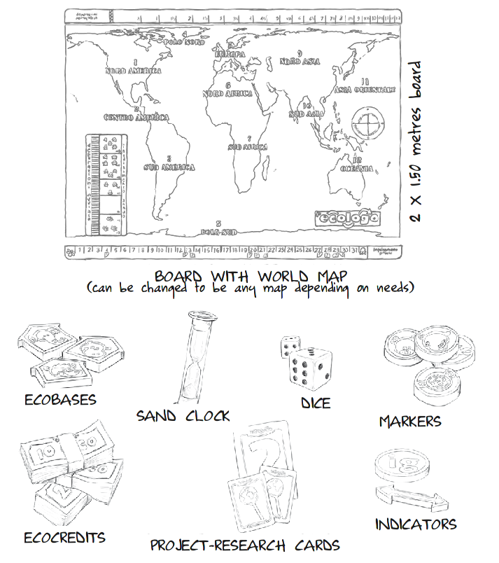
SHORT DESCRIPTION
Players are ecologists who travel across the world discovering ecosystems. Knowledge and experience will allow them to face natural catastrophes, caused by increasing pollution, that crush planet Earth at an higher and higher rate.
PROJECT: A SCUOLA CON L'ECOLOGO
(AT SCHOOL WITH THE ECOLOGIST)
(target: kids from 8 to 16 years old)

GENERAL OBJECTIVES
To contribute in a sensitive way to the civic and social training of the student, by helping him achieving awareness of what he/she already knows and of benefits of collaboration, to became self-consciousness and critic.

STRATEGIES
- questions to trigger narration of personal experiences, to be shared with others
- guided approach in building connections between experiences and to structure them in an organic way
- everybody takes part in shaping knowledge, that then becomes public domain
- debate between ecoeducators (see definition later in this document) to cast doubt
- learning path that follows the scientific method: observation, deduction, definition of hypotheses, proof of hypotheses via experiments, generalization.

CONTENTS
- general topics and meta-contents: pollution, human impact, climate changes, sustainable development, best practices for building an ecological civic responsibility, collaboration.
- Scientific themes (and more), to be agreed together with the teacher.

VERIFICATION
- observation of behaviour changes during a game session, as a proof of a correct interaction with the environment
- debriefing: at the end of a game session, students discuss about what happened during game-play.

INSTRUMENTS
- playground: a schoolroom where desks are moved to the walls, so to have space in the middle. Otherwise a gym or some large open space.
- time: a game session lasts a whole morning (4-5 hours). Alternative options can be agreed (the game can be “saved”)
- players must be organized in teams

COSTS (this applies for Italy. For other countries it may vary)
Average of 1,50 Euro/hour per student per game session, lead by two ecoeducators.
(prices may vary with respect to: country, number of participants, duration of activity, way of carrying on the activities. A monthly fee can also be arranged.)
ECOEDUCATORS

- science experts
- play as actors: they might emphasize their roles using masks and costumes
- drive each player to connect experiences to gain self-awareness of his/her knowledge, competencies, skills
- continuously interacting with players and other ecoeducators
- apply the method presented above
- passionate, they have fun while playing.

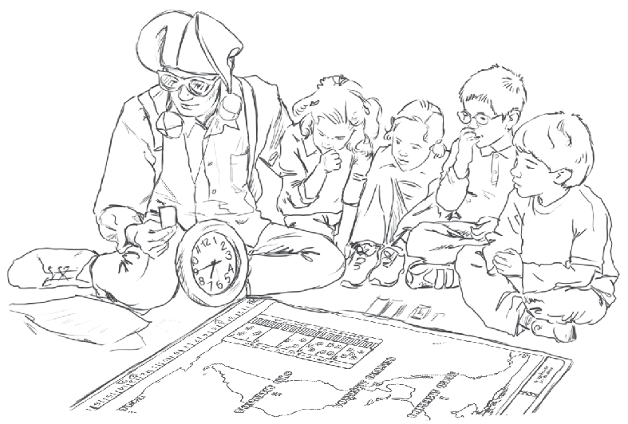
BEYOND SCHOOL

- Training course for teachers (7 days of lab to understand how to present the game to their own classes)

The service has been successfully tested in schools in the area of Rome, Italy.
It has also been reshaped to fit some public events, among those:
- Parco di Veio, Campagnano di Roma (RM), Italy.
A national park. The park features are discovered while playing, with guided tours around the game area.
- Ecobiketour in Ostia, Roma (Italy)
Village event. Sustainable traffic. The map was changed into local areas of the village, and the topics were focused on green strategies.

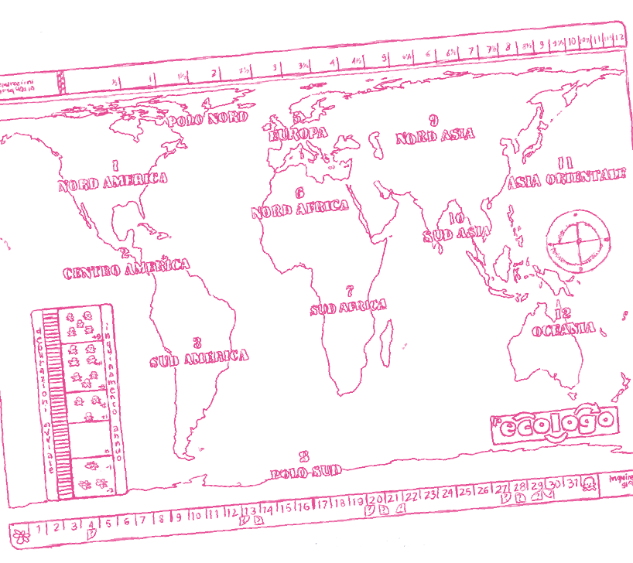
L'ecologo (the ecologist) is a table game based on an ecological model of human impact over Earth's ecosystem, invented by Massimiliano Desideri and developed with the aid of Giuseppe Morlino, Florido Paganelli, Giulia Casini, Claudio Capobianco, Davide Santarsiere and more others!

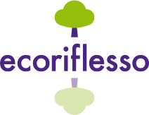
Info:
Associazione Ecoriflesso
website: www.ecoriflesso.org
e-mail: ecoriflesso@gmail.com
Phone numbers
Florido Paganelli 0046 7 000 53 116

